*The Mating Game* provides a hands-on activity students can use to explore fundamental Mendelian genetic mechanisms: the laws of segregation and of independent assortment. Students draw pairs of colored chips (3/4” markers made from coins or plastic discs) that represent gametes bearing alternative alleles that exist in the gene pool of a segregating population. They place them on a simple playing board that can be printed on standard 8½” x 11” sheets of paper. Having stipulated the dominance relationship between alternative alleles at a single locus, students are challenged to predict the phenotype of simulated F2 progeny individuals, and to calculate phenotypic ratios and allelic frequencies in the population they created. The activity makes it clear that the canonical 3:1 phenotypic ratio is a simple and entirely predictable outcome that emerges due to Mendel’s law of segregation. Students then repeat the *Mating Game* activity but model the phenotypic outcomes expected if there are two genetically unlinked loci in the gene pool; they will “discover” that Mendel’s law of independent assortment is a logical extension of his law of segregation simply as applied to allelic variants at multiple loci. Variations on the *Mating Game* theme are also described that help students to understand the principles of genetic linkage and of natural selection.

The mechanics of *The Mating Game* engage students at multiple sensory levels: auditory circuits are activated by the sounds of chips (alleles) being shaken in coffee cans or plastic cups. Tactile and kinesthetic senses are stimulated by the act of drawing gametes from the gene pool and placing the pairs on the game board. *The Mating Game* especially engages student visual pathways. Alternative alleles are distinguished by using chips of different colors that were selected to subtlety reinforce the functional distinction between dominant (green, blue) and recessive (yellow, red) forms. By playing the game alongside living F2 plant populations in which alternative alleles at a single locus are segregating to yield clearly distinguishable phenotypic outcomes—populations that the students themselves planted and grew just a week earlier-- they can readily see a “real world” enactment of the genetic mechanisms the activity is intended to model.

Anticipated educational outcomes from the activity suffice to meet multiple expectations/objectives of the Next Generation Science Standards as well as the revised AP Biology curriculum in areas ranging from genetics and evolution to quantitative reasoning. Supplemental materials are described here that enable educators to entertain a wide range of student learning styles—from hands-on learners to abstract thinkers who may interested, for example, to use computational (excel spreadsheet) approaches to model genetic processes. Materials required to conduct *The Mating Game* activity are inexpensive and readily available; I describe here how you can fashion your own playing pieces or purchase them from on-line sources. The exercise, complete with optional variations, can be completed in a single 45 minute class period in which students progress from a simple one-locus simulation to more sophisticated and abstract (unlinked *versus* linked) two-locus models. The playing board serves as a pedagogical scaffold to aid students in that logical progression and a worksheet of questions related to the activity is provided that serves a similar function-- and at the same time enables teachers to assess advancement of student learning outcomes.

*The Mating Game* has been developed by Associate Scientist Scott Woody, Director of the Genetics Resource Development Center in the Biochemistry Department, University of Wisconsin-Madison. The activity is intended to advance our primary mission of providing more effective tools to help students understand and appreciate fundamental Mendelian genetic principles—not as an end in itself, but as a means to help students to better understand the evolutionary processes that have worked over the course of ~3.5 billion years to shape the biological world that we see everywhere in nature and especially in our own species, *Homo sapiens*. The game made its public debut in an exhibition hall booth sponsored by the American Society of Plant Biologists (ASPB) in the context of the Family Science Days (FSD) outreach event staged during the 2014 annual convention of the American Association for the Advancement of Science (AAAS). FSD is a wonderful opportunity for ordinary citizens—moms, dads and kids; scientists, science educators, and just curious humans—to hobnob with working scientists from diverse settings and fields of inquiry. Played there by visitors to the ASPB booth alongside living FPsc (“Fast Plants, self-compatible”) populations in which the *albino* (*alb*)mutant allele was segregating to yield vital green *wild-type* (*wt*) seedlings andyellow *alb* F2mutant segregants in a 3:1 (*wt:alb*) phenotypic ratio, *The Mating Game*, even as presented in single-locus form, had the evident effect of “flipping the switch”, enabling participants both young and old, to realize the simplicity of Mendelian genetic principles once the curtains were drawn back to reveal the mechanics of those fundamental biological laws.

I became energized and motivated by the enthusiastic reception of *The Mating Game* by attendees at FSD to draft this more-or-less formal description of how the game might be used in academic classroom settings. As with all things related to the FPsc genetics education program, especially this web site, *The Mating Game* remains very much a work in progress and so I expect revised/refined versions will be released over time. A particular interest of mine is to use *The Mating Game* exercise as a means to help students to transition from using Mendelian genetic analyses-- in which overt phenotypic differences among F2 segregants are useful to help students to understand the principles of inheritance, as elegantly described by Mendel in the 1850s-- to the much more powerful 21st century molecular genetic approaches that take full advantage of recent and astounding advances in DNA sequencing technology to help us connect organismal phenotypes with underlying, DNA sequence-based genotypes.

Those revisions will be produced and released as time and circumstances permit. In the meantime, I humbly offer this implementation guide in hopes that teachers and their students may find it of use. Your feedback, as always, is invited and can be sent via email to me at [swoody@wisc.edu](mailto:swoody@wisc.edu). I especially look forward to your suggestions on how to improve the exercise itself and/or the supplemental implementation guide and extension activities.

Scott Woody, March 9, 2014

**Materials required**

1. *The Mating Game* playing board(s), available for download in pdf format **here**. The figure below provides thumbnail sketches of the three panels used to during full implementation of the activity. Panel 1a provides scaffolding for the single-locus implementation that is sufficient to illustrate Mendel’s law of segregation. Panels 1b and 1c provide the opportunity to expand the exercise to two (linked or unlinked) loci in order for students to better appreciate Mendel’s law of independent assortment.

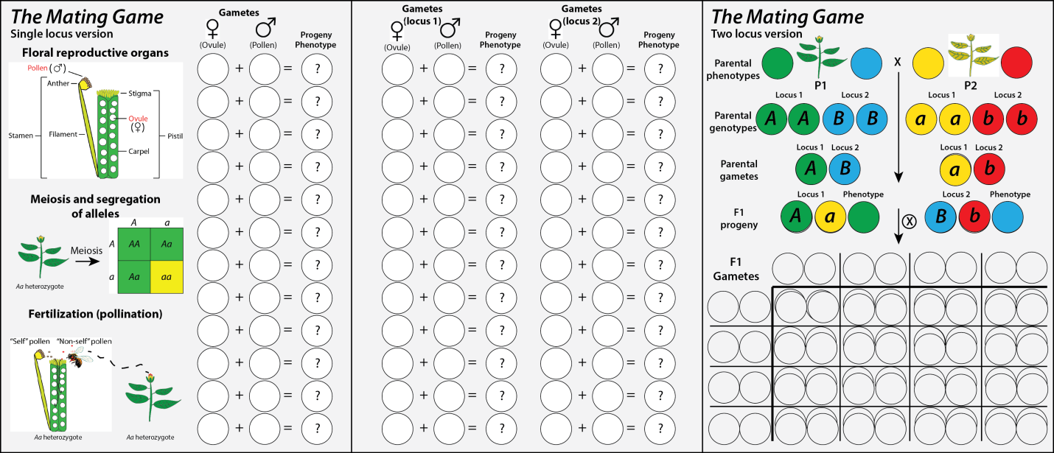

**(a) (b) (c)**

**Figure 1: *The Mating Game* playing board panels**

2. A worksheet students will complete while playing *The Mating Game* is available for download in **pdf**or**MS Word** formats. The latter provides greater flexibility to teachers who may be interested to modify the lesson plan. For instance, although not presently included, I certainly would suggest that teachers take the opportunities to challenge their students to conduct chi-square analyses as might be warranted.

3. Chips or other colored makers to represent gametes/alleles and predicted phenotypes and a container to hold alleles circulating in the simulated gene pool. Each full implementation of *The Mating Game*, whether by individual students, pairs, or teams will require a total of about 100 markers of each of four colors. In order to fit all pieces on the playing boards each chip should be ¾” in diameter or less. US pennies adorned with adhesive colored dots (*e.g.,* Averyproduct #5468 that I found available at a local big-box office supply store) have worked well for me. Gamete/allele markers are distinguished from chips used to represent phenotypes by upper or lowercase letters inked onto the former; phenotypes are indicated by solid-color, unlabeled chips (Figure 2). An alternative for penny-based markers is to purchase a similar number of plastic game chips on-line (*e.g.* <http://www.greathallgames.com/aacc/atokbags/achipsDrops.html> , scroll or search for “tiddlywinks”).

Whether playing a one-locus or two locus game it is important that alternative alleles (differently colored and labeled pieces) should be presented to students at equal frequency in the container (a coffee can or large drinking cup) that might be labeled “Gene Pool” from which alleles will be drawn. Finally, and perhaps this should go without saying, alternative alleles at discrete loci (generically referred to as locus 1 and locus 2 in Figure 1 panels b and c) should be held in separate gene pool containers (green/yellow in one coffee can, red/blue alleles in another).

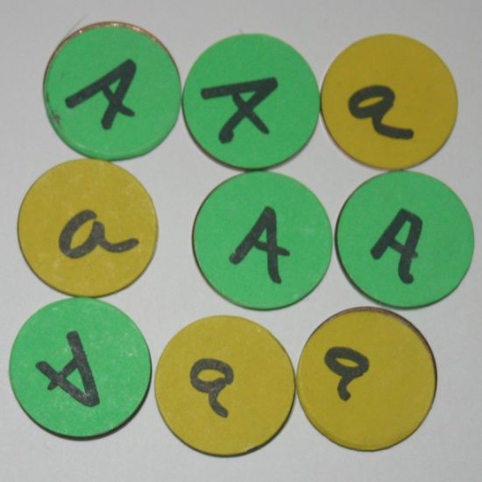 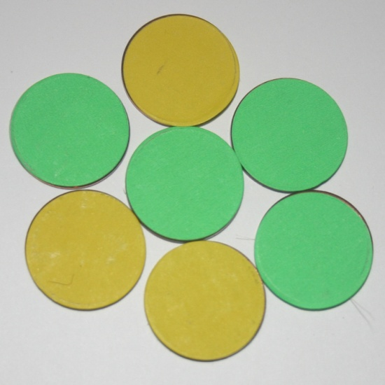

**Figure 2: Colored playing pieces (US pennies) are labeled to indicate alternative alleles (left panel) or left blank to indicate predicted phenotypes (right panel).**

4. One standard 6-sided die, used to simulate linkage in an advanced two-locus game.

5. Segregating F2 population(s) of student-grown plants: Here I will suggest that you make use of the FPsc *albino* (*alb*)and *abnormal leaf* (*ale*) genetic stocks Figure 3), available upon request via email ([swoody@wisc.edu](mailto:swoody@wisc.edu)). These two well-behaved (in a Mendelian genetic sense) alleles epitomize the behavior of recessive and dominant alleles, respectively, as passed by gametes from parental to progeny generations. Please note that *The Mating Game* is suitable for use with almost any pair of mutant alleles whether from the FPsc collection or others. For instance, the *purple stem* phenotype is commonly built into genetic stocks on offer from the Wisconsin Fast Plants; if used, it would perhaps be sensible to adjust allele/phenotype color schemes accordingly.

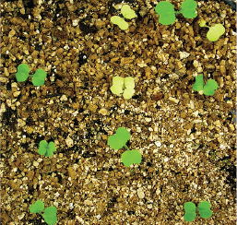 **ale leaf hires.tif**

**Figure 3: FPsc genetic stocks recommended for use in *The Mating Game*.** An F2 population in which the *albino* (*alb*) recessive mutant allele is segregating is shown at left. A curled leaf caused by the dominant *abnormal leaf* (*ale*) allele is shown at right. F2 populations should be planted and grown for two weeks prior to use in this exercise.

**Playing *The Mating Game***

Print and distribute copies of the game board panels that comprise *The Mating Game* as well as the accompanying worksheet. Place sets of alternative alleles in equal numbers (~40 each) in the container that will serve as the gene pool. Additional allele tokens as well as the discs used to indicate the corresponding phenotypes (at least 12 of each alternative color) should be placed in a separate container or simply laid in a pile aside the playing board.

I will leave it to teachers to decide how much scaffolding is provided in introductory remarks. For instance, the small green/yellow Punnett square shown at center-left of panel a (Figure 1) may be sufficient to allow students to infer the dominance relationship between *A* (green) and *a* (yellow) alleles

Whether the exercise is used to simulate a one-locus or a two-locus scenario, game play is straightforward: students draw pairs of gametes/alleles from the gene pool(s) at random and place the discs atop circles on the game board. Students are then challenged to predict the phenotypes of progeny individuals based on the genotypes drawn. I suggest starting the exercise by modeling a one-locus scenario using only panel (a) to help establish the general pattern of game play. Figure 4 illustrates the game board as might result after students create 12 simulated progeny individuals.

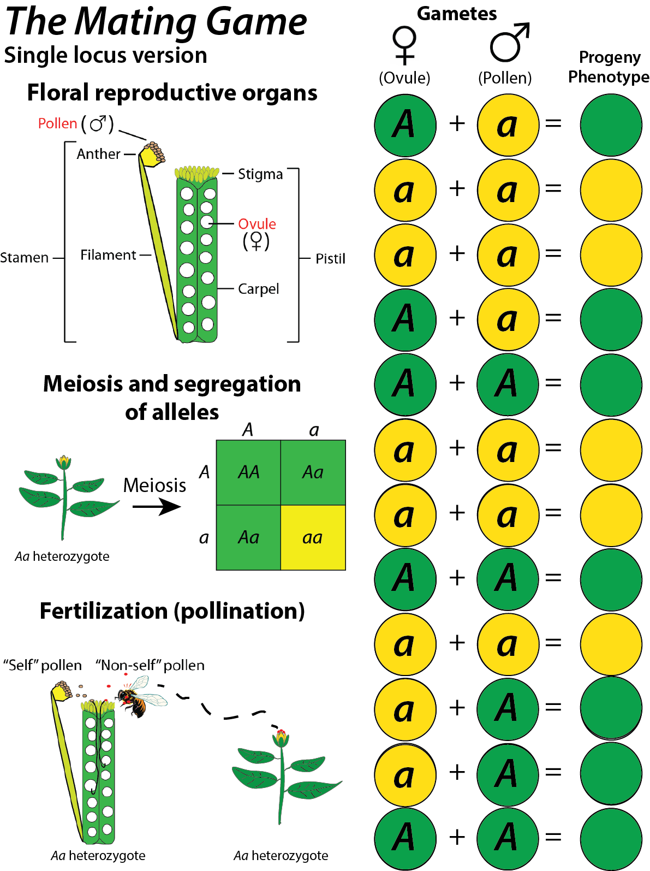

**Figure 4: Completed single-locus scenario**

Turning to the worksheet, have the students score their progeny populations with respect to phenotypic, genotypic and allelic ratios (questions 1-4). It is quite likely that one or more student teams will have generated progeny families whose genotypes do not conform precisely to those ratios predicted by Mendel’s law of segregation and here would be a good opportunity to introduce the chi-square test to evaluate the statistical “fit” of student data compared to predictions of the inheritance model shown at center left in panel (a).

Question 5 directs students to aggregate data from all student teams and to repeat the calculations of questions 1-4 by using the larger set of results. There are at least two good reasons for this. First, a bit of repetition can be useful to solidify students’ understanding of the mechanics involved in genetic analysis. Second, in so doing, students should come to a better appreciation that genetics is, at the most fundamental level, simply a numbers game in which chance deviations from predictions can often be smoothed-out with increasing sample size.

**Variation on the single-locus scenario to illustrate the power of natural selection to cull deleterious alleles from the gene pool of a population**

If you are using the FPsc *albino* F2 population as visual aid in *The Mating Game* this variation is a quick and, I think, powerful way to help students to understand that natural selection can work through straightforward genetic mechanisms to remove deleterious alleles from a population over the course of successive generations of growth and reproduction. Stipulate to students that *albino* mutant segregants, although remarkably persistent, will ultimately be unable to flower and pass their *a* alleles along to the next progeny generation. Thus, the *a* allele frequency in the population will fall over time as a result of *differential fitness* effects conferred by *A* and *a* allelic alternatives. Obviously this is an extreme example given that the *relative fitness* of the *a* allele is precisely 0 under classroom conditions (as compared to the superior relative fitness conferred by the *A* allele, but it seems a very short intellectual leap for students to see that any allele with relative fitness less than that of an alternative allele that may be circulating in the population will likewise decline in frequency over time.

Thus, let’s return to the simulated progeny population. Have students remove all yellow markers (both labeled alleles and the phenotype chip) that represent the *aa* genotypic class. Set those alleles to the side—**do not return them for the moment to the container used to hold the gene pool.** In the case of the population shown in figure 4, above, five *albino* mutant segregants among the 12 progeny would be removed from the board. Emphasize to students that populations in nature tend to maintain a constant size as determined by resource availability. Elimination of *albino* progeny individuals leaves room for *wt* segregants to contribute their alleles to the next generation. To simplify replacement of the *albino* segregants and to maintain a total population of 12 individuals, identify the genotype of the nearest *wt* segregants flanking the (now dearly departed) *albino* segregants. Draw from the gene pool container a pair of green chips (*A*) or a green and a yellow allele (if the flanking *wt* individual is an *Aa* heterozygote).

Challenge students to complete questions 1-5 from the worksheet by inspection of phenotypic, genotypic, and allelic ratios in the modified populations that were subjected to selection. To speed the exercise along it may be useful to have students consider just their own data sets and skip aggregation and consideration of all student data (or *vice versa*).

Question 7 asks students to think broadly about changes in *A* and *a* allele frequencies over time under this single-locus (with selection) scenario. I declined to offer any scaffolding to guide students in drafting plots of *f(A)* and *f(a)* over successive generations, hopeful that they might reason their way to a simple x-y plot where “Time” or “Generations” is plotted on the x axis and allele frequencies are plotted on the y. Question 8 is related but intended to help students to understand that although *f*(*a*) may fall rapidly from 0.50 in early generations, the frequency only asymptotically approaches zero over the course of later generations. It is my hope (however naïve) that students will recognize, by simple inspection of the alleles now comprising the gene pool, that while *f*(*a*) falls over time/successive generations, to be replaced by *A* alleles which confer reproductive competence, and thus superior fitness, the odds of two *a* alleles combining upon fertilization to yield an *aa* homozygote simultaneously decrease, diminishing the power of natural selection to rid the population of those deleterious alleles.

**A two-locus *Mating Game***

Return all allele game pieces from the one-locus game board, including those yellow *a* alleles culled by selection against sterile progeny plants, to the gene pool container. Thoughtful readers will recognize that by doing so players will have slightly perturbed the 1:1 *A:a* allelic ratio of the original gene pool but unless the one-locus game (with selection) had been played to simulate more than a couple of generations the effects should not have a significant effect on genotypic and phenotypic outcomes obtained in the course of playing a two-locus model.

Ask students, first, to repeat the *Mating Game* simulation by using the same gene pool used in the single-locus game to generate 12 new progeny individuals whose genotypes and predicted phenotypes are placed on circles of the left (“locus 1”) columns of *The Mating Game* panel (b) (see Figure 1). Now ask students to select allele pairs from gene pool 2, a separate container holding chips that represent alternative allelic forms at a different locus (“locus 2”), and place those pairs alongside locus 1 alleles. If desired you can ask to students to repeat the data reporting and calculations of questions 1-5 but, as the two-locus scenario is intended to emphasize Mendel’s law of independent assortment of alleles at discrete genetic loci, doing so may take time and attention away from the task at hand. Instead, you might consider using the two-locus data as a homework problem based on data collected from the two-locus model as described in the following.

Question 9 of the worksheet asks students to report their observations regarding progeny genotypes and predicted phenotypes in a tabular format. Please note that the new progeny data recorded in the table are really no different than that collected in the single-locus game, the results are merely summarized in a different format from which all of the same genetic analyses regarding phenotypic, genotypic, and allelic ratios can be derived.

*The Mating Game*, two-locus version, now requires a bit of a digression to consider panel c of the playing board. There students should model all possible genotypic and phenotypic outcomes that might result from segregation of alleles at two discrete and genetically unlinked loci at which the several allelic combinations at each locus act to program discrete phenotypic attributes. In the scenario I describe here, locus 1 alleles and phenotypes are assumed to model segregation of the *wt* and *alb* mutant alleles that condition pigmentation via differential activities at the *albino* locus. The dominance relations and hence phenotypic consequences of alternative allelic configurations at locus 2 are left undefined in this implementation guide but could be stipulated by the instructor. My personal preference would be to posit that locus 2 models the effects of *wt* and the dominant *FPsc abnormal leaf* (*ale*) allele on leaf morphology—primarily because the 1:3 phenotypic ratio observed in a segregating F2 population may cause students to ponder the functional distinction between *wt* and “mutant” alleles, but any locus at which alternative allelic forms exist that condition different phenotypic outcomes would suffice in the exercise.

Panel c of *The Mating Game* playing board challenges students to model a dihybrid cross in which two parental *B. rapa* lines, each carrying alleles at locus 1 and locus 2 in homozygous condition, are crossed to create an F1 progeny generation that is heterozygous at both loci. Students can be asked to model genotypic and phenotypic outcomes among progeny of such a cross or can simply be walked-through the genetic gymnastics that might lead to the game-play scenario shown in Figure 1, panel c, in which all of those preliminary events are depicted by using game pieces taken from gene pool containers or extras that were prepared and set aside the game board in advance.

There are four equally probable allelic combinations that students should derive from the genetic progression shown at top in panel c: *AB, Ab, aB,* and *ab*. By hook or by crook, lead them to place allelic markers across the top and far left of the Punnett square outline provided at the bottom of panel c. A critical pedagogical point in *The Mating Game* two-locus exercise is to get the students to calculate the frequency of each gametic class—this will be the point of emphasis when the exercise turns, later, to the special circumstance in which locus *A* andlocus *B* are modeled as if genetically linked. In this first case of unlinked loci, though, the odds are pretty easy to figure: each alternative allele at *A* has a probability of being picked equal to 0.5 and the same applies to alleles at the *B* locus; the odds of particular outcomes in successive independent trials is the product of individual probabilities, so 0.5 x 0.5 = 0.25, or 25%. Space is provided above the several gametic/allelic combinations at the top of the Punnett square in panel c to prompt students to consider those frequencies, but please have them record their predictions by using the table in worksheet problem 10; the playing board values will change when we shift to a two-locus (with linkage) inheritance model so to avoid erasures and confusion it may be best to leave those spaces blank on the playing board itself.

By placing allelic markers—taken either from the gene pool containers or the extras alongside the playing board—have students predict the genotypic outcomes in each of the 16 rectangles of the Punnett square provided in panel c of *The Mating Game* playing board. Warning: after downsizing the game to fit on an 8 1/2” x 11” sheet, the rectangles don’t allow much room for all four alleles that will come to live in each one. I recommend that students be instructed to stack alleles at each locus, as combined in each rectangle, such that the dominant allele is placed atop the alternative recessive allele in each pair in order to visually convey phenotypic outcomes at the locus. Figure 5 illustrates panels b and c as they might appear following completion of this phase of the two-locus game.

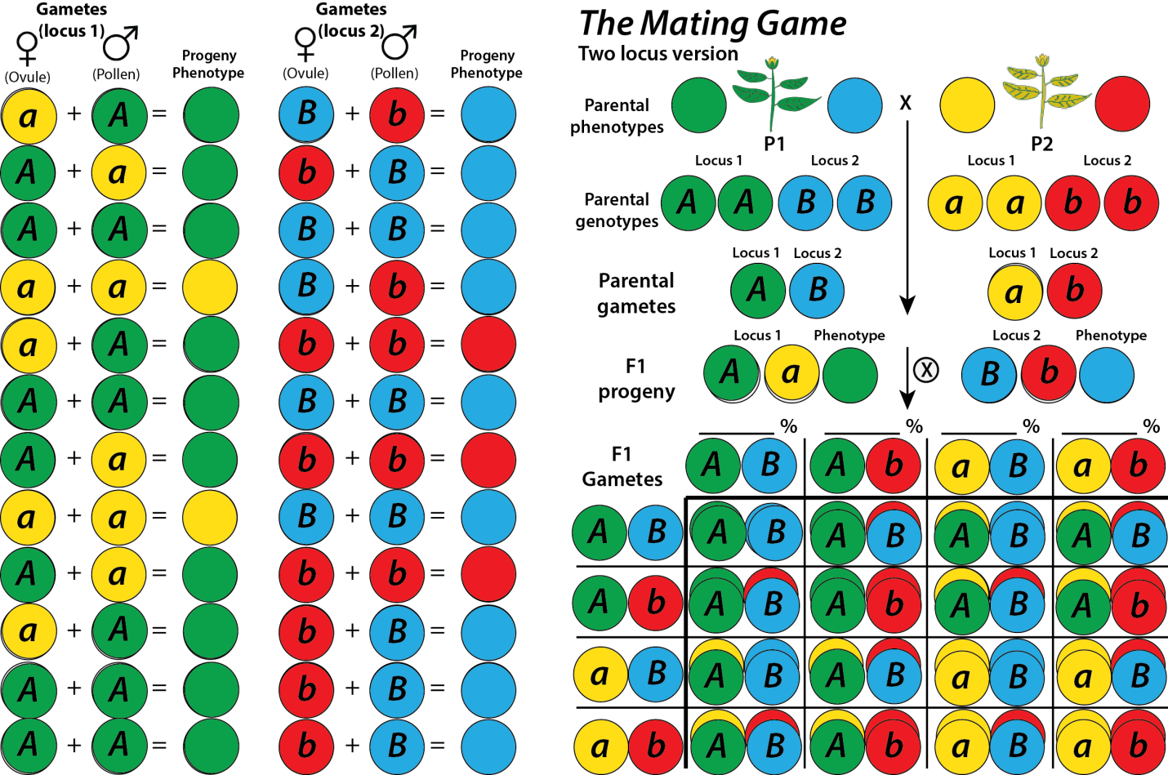

**Figure 5: Completed panels b and c in a two-locus rendition of *The Mating Game*.**